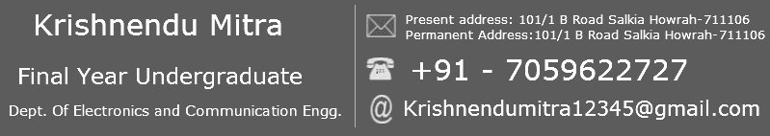

|  |
| --- |
| Looking for an organization to work that provides me the opportunity to improve my skills, where my knowledge will Get exposure to real life problems and enrich me with experience and let me grow with the growth of the company. |

|  |
| --- |
|  |

Education

|  |  |  |  |  |  |
| --- | --- | --- | --- | --- | --- |
| Degree | Branch | Year of Passing | College/School | University/Board | Percentage |
| Bachelor of Technology | Electronics and Communication Engineering | 2018 | Techno India, Salt Lake | Maulana Abul Kalam Azad University of Technology | 7.75  (Upto 7th Semester) |
| Higher Secondary – XII | - | 2014 | Salkia Hindu School,Howrah, West Bengal | West Bengal Council of H.S. Education | 66 |
| Secondary – X | - | 2012 | Ramakrishna Vivekananda Mission Barrack pore | West Bengal Board Of Secondary Education | 77.14 |

Technical Skill set

|  |  |
| --- | --- |
| Skills | Details |
| **Programming Languages** | C, Core JAVA, |
| **Operating Systems** | Microsoft Windows 7, Windows 8, Windows 10 |
| Known IDEs | Code blocks, Eclipse, Microsoft Visual Studio 2015,Matlab 2015, |

UG Engineering Project - Details

|  |  |
| --- | --- |
| **Project Title** | |
| **Domain** | Embedded Systems and IOT |
| **Project Description** | * Making an Embedded system used for image printing. * The System is used for Designing, Graphics and Print Finishing, General Woodworking, Sign making etc. * Mentored by Professor AKD, HOD Of ECE dept.(Techno India Salt lake College) |
| **IDE Used** | * Arduino 1.8.2, Inkscape |
| **Duration** | * Sep, 2017 - Sep, 2018 |

Summer Training Project – Details

Training - Details

|  |  |
| --- | --- |
| **Training Details** |  |
| **AIR INDIA** | * Vocational training on wireless Radio and Satellite Communication for 2 Weeks. |
| **IBM** | * Object Oriented Programming using  JAVA (Core JAVA) (Dec, 2015 – Jan, 2016) |
| **Oriens Infotech pvt.ltd** | * C Programming Language |
| **Edwisor.com** | * I am continuing MEAN Stack Program from Edwisor.com (till now I am at the middle of this program. I know HTML5,CSS,JQUARY,JAVASCRIPT,JSON file Handling) |

Personal Skills

* I have good communication skill and fast decision making ability.
* Have good patience which I believe will lead to better human relation.
* Good in team work.

Area of Interest

* Embedded Systems and IOT
* Object Oriented Programming Concepts (JAVA).
* Database Management System.

Achievements

* Active member of Official Science Club “GEEKONIX” of TECHNO INDIA, 2015-till date.
* Participate in National Symposium on Internet Of Things: Trends And Opportunities ahead NSIOT 2016, Organized by Institution Of Engineering And Technology (UK) at jadavpur University
* Active member at Institution Of Engineering And Technology (UK)
* Participate in ETHICAL HACKING Workshop on TECHNOCRUISE 2016 Event Conducted By IIT Kanpur
* Actively participated in different robotics events and other events in different colleges.

Leisure Interest

* Surfing Internet for new technologies developed till date.
* Watching Movies.

|  |
| --- |
| I, Krishnendu Mitra, hereby declare that all the information provided above is true to the best of my knowledge. |

**Disclaimer:**

PLACE : Howrah

(Krishnendu Mitra)